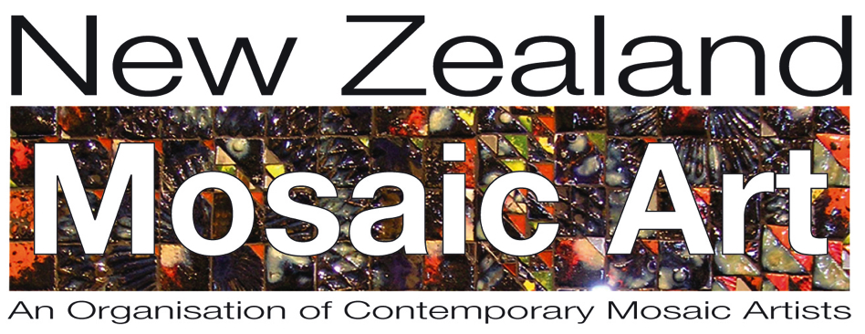

Application Form

Membership to New Zealand Mosaic Art Incorporated

✔ I accept Rule 11.0 of the NZMA Inc Rules
Rule 11.0 of the NZMA Inc Rules states the 0bligations of Society Members
11.1 All Society Members shall promote the purposes of the Society and shall do nothing to bring the Society into disrepute.

Name

Address

Email

Phone

Membership Fee is $45 per annum.

I have transferred the membership fee to the NZMA bank account: Yes/No

Bank details for Direct Credit: New Zealand Mosaic Art Incorporated,
ANZ Bank 06 0299 0254135 03

Please quote your name when processing your direct credit

You can contact us at mosaicartnz@gmail.com

Welcome to New Zealand Mosaic Art incorporated

