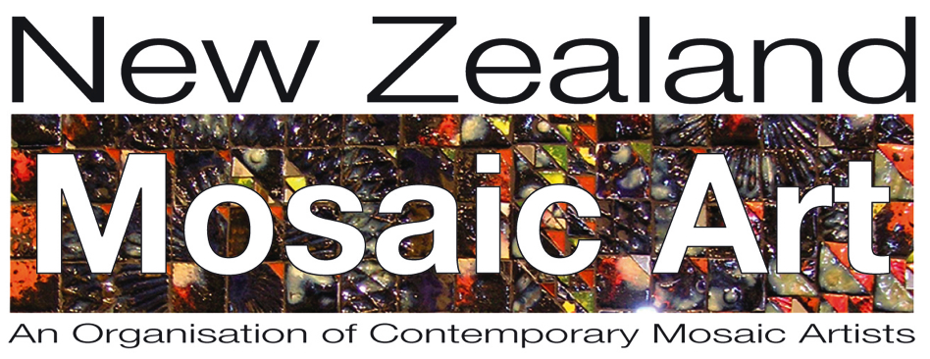

Application Form

Membership to New Zealand Mosaic Art Incorporated

Note: Clause 9.0 of the NZMA Rules states the 0bligations of Society Members
9.1 All Society Members shall promote the purposes of the Society and shall do nothing to bring the Society into disrepute.

Name

Address

Email

Phone

Membership Fee is $30 per annum.

I have transferred the membership fee to the NZMA bank account : Yes/No

Bank details for Direct Credit: New Zealand Mosaic Art Incorporated,
ANZ Bank 06 0299 0254135 00

Please quote your name when processing your direct credit

Send this form to mosaicartnz@gmail.com

Welcome to New Zealand Mosaic Art incorporated

